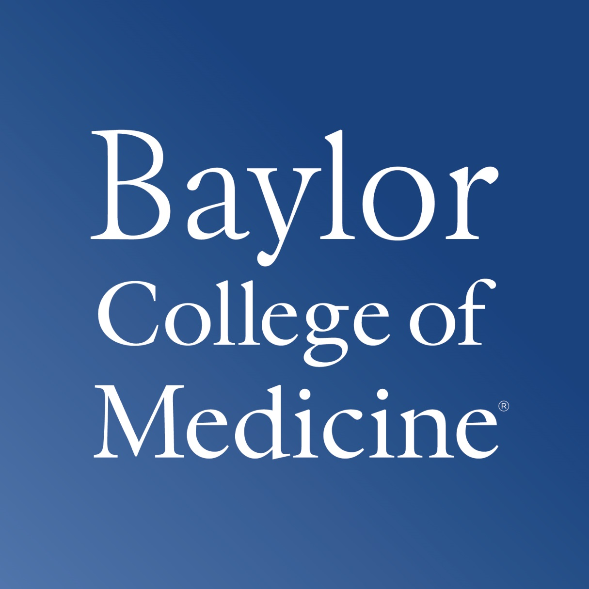

**DEPARTMENT OF MOLECULAR**

**VIROLOGY AND MICROBIOLOGY**

**Robert A. Britton, Ph.D.**

One Baylor Plaza, Room 739E

MS: BCM385

HOUSTON, TEXAS 77030-3411

rabritto@bcm.edu

March 5th, 2019

**Principal Investigator:** Leigh Greathouse, PhD, MPH, MS, RD

**Co-PI:** Robert Britton, Ph.D.

**RE:** Illuminate Proposal

Dear Review Committee,

As Professor of Molecular Virology and Microbiology at Baylor College of Medicine, I fully endorse the proposed study **Development of precision medicine prebiotics using mini-bioreactor arrays (MBRAs)**.

I am excited to be a part of this study and to assist Dr. Greathouse and Baylor University in establishing the MBRA system. As original developer of this system, I have expertise in all aspects of set up and experimental design, which makes me well-suited to serve as Co-Principal Investigator on this Illuminate Proposal. Our laboratory is interested in understanding how the intestinal microbiota provides a barrier to incoming pathogens and how perturbations of the microbiota result in an established infection. We have focused most of our attention on the pathogen *Clostridium difficile*, which is the most common cause of antibiotic associated diarrhea. We developed the mini-bioreactors and mice colonized with a human intestinal microbiota to address which members of the community are responsible for inhibiting *C. difficile* invasion. Thus, our research is complimentary and potentially synergistic.

The results from this study will lay the ground work for a larger multi-phase study that is well-positioned to address the need for prebiotic formulations and treatments to combat infections. Given that the NIH will be announcing a large multi-center funding strategy to support nutrition research, this proposal is well timed to ready Baylor to take advantage of this funding opportunity. Ultimately, this research will lead to a deeper understanding of the dietary prebiotic fibers that modulate the gut microbiome, and identify the prebiotics that support microbial communities capable of both resistance to and eviction of pathogens.

I have little doubt that this project will develop into a highly impactful long-term collaboration with exceptional external funding opportunities from multiple agencies, and that will generate innovative research on the diet-microbiome relationship. Overall, I am well positioned to provide excellent support for this study and we look forward to collaboration to facilitate Baylor’s mission of R1 Status.

Best regards,

Robert Britton, PhD

Therapeutic Microbiology Laboratory

Professor, Department of Molecular Virology and Microbiology

Member, Alkek Center for Metagenomics and Microbiome Research

Baylor College of Medicine, Room 663E

[rabritto@bcm.edu](mailto:rabritto@bcm.edu)